Lab 1 : Basic Linux Commands

1. Command: **ls**

Interpretation: List contents of the current working directory

Output:

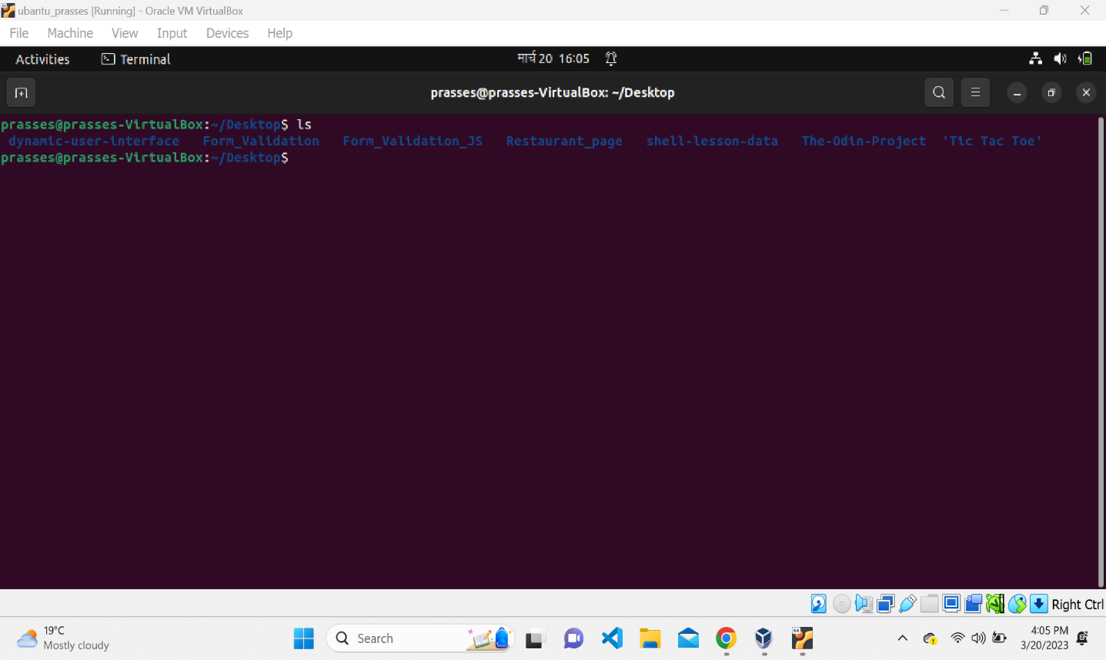

1. Command: **dir**

Interpretation: List information about the FILEs (the current directory by default).

1. Command: **ls -a**

Interpretation: List contents of the current working directory where option -a is used for displaying all the contents of the directory along with entries starting with.(dot)

1. Command: **ls -l**

Interpretation: List contents of the current working directory where option -l is used for displaying contents of the directory with a long listing format

1. Command**: ls -lh**

Interpretation: List contents of the current working directory where option -lh is used for displaying contents of the directory with a long listing format with human understandable sizes like 1K 234M 2G etc.

1. Command: **ls -F**

Interpretation:

**Output:**

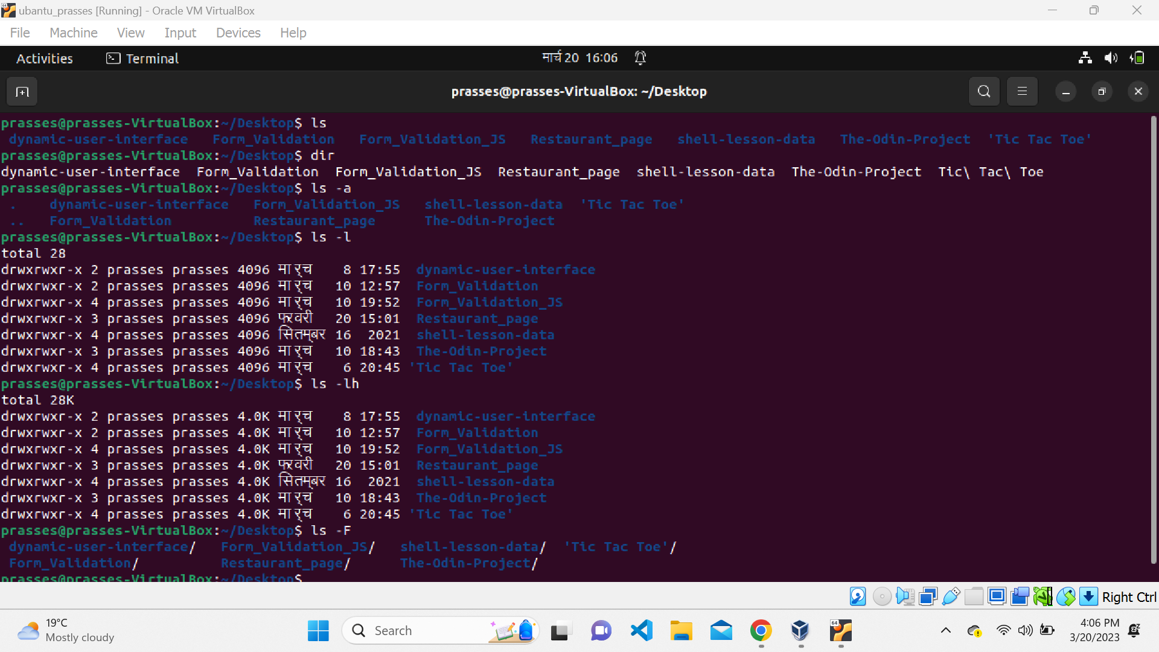

1. Command: **ls -r**

Interpretation: List the contents of directory in the reverse order while sorting

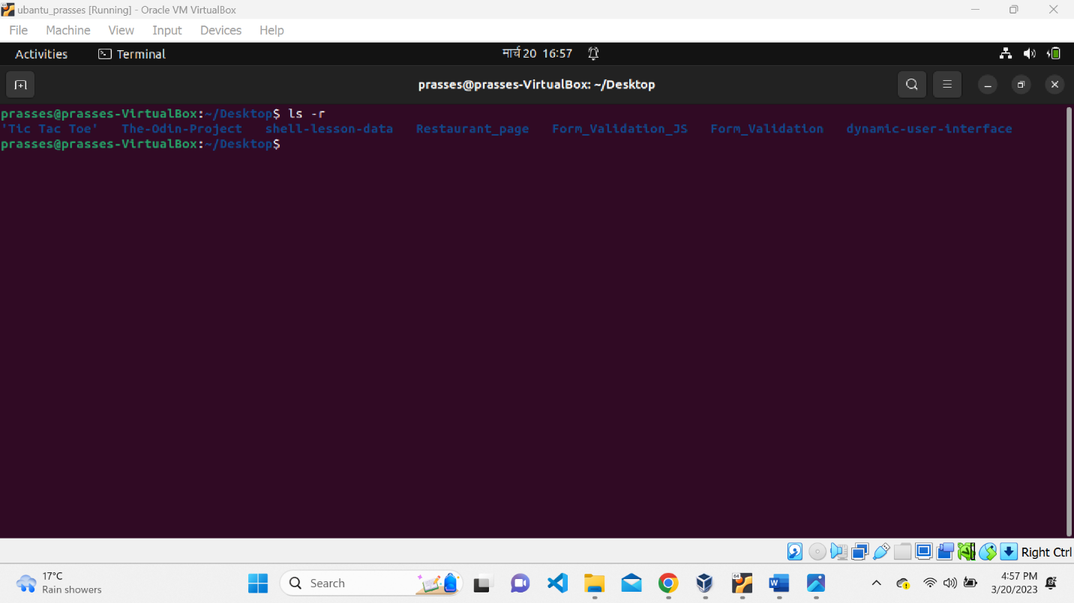

1. Command: **ls -R**

Interpretation: List the contents of the current working directory and subdirectories recursively

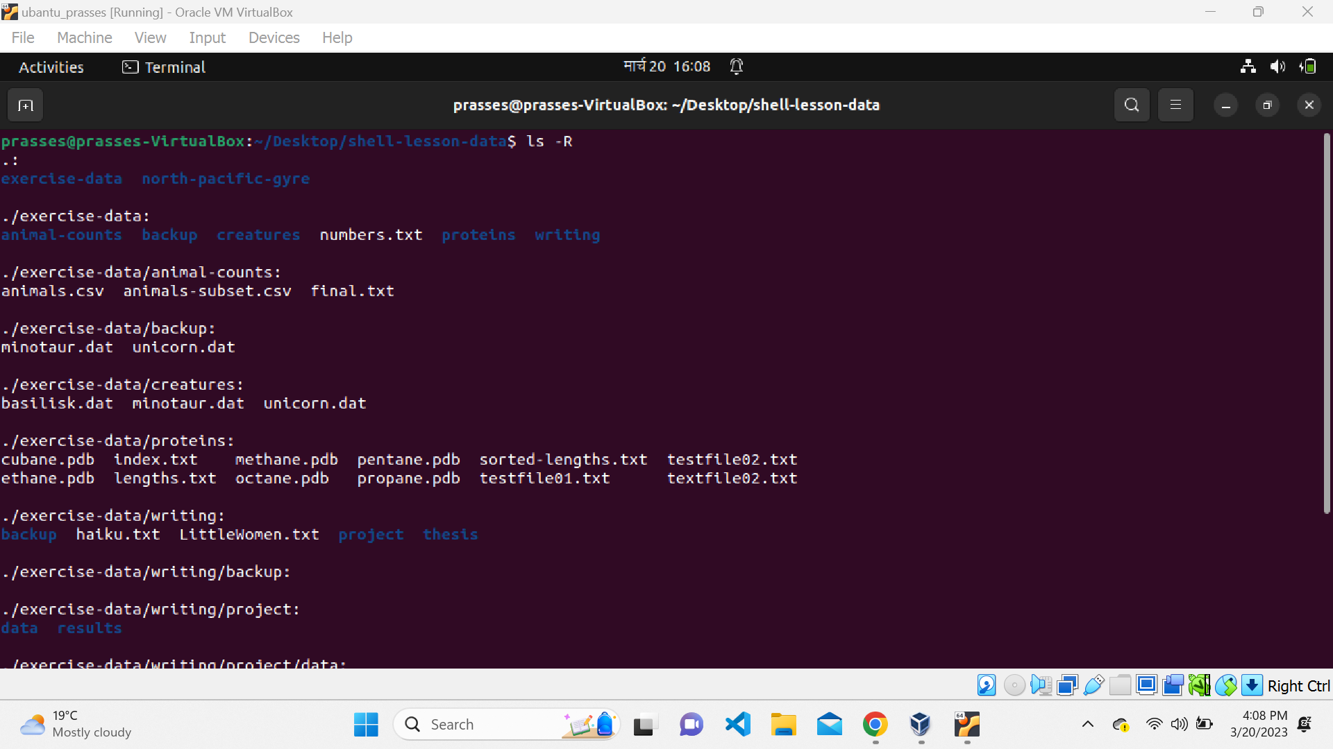

1. Command: **ls -ltr**

Interpretation: List the contents of the current working directory where -l displays in longlisting format and -t sorts by time, (newest first) and -r reverse the order while listing So the content of the directory is listed in long listing format sorted by time(oldest first)

1. Command: **ls -i**

Interpretation: List the contents of directory with index numbers

1. Command: **ls –version**

Interpretation: Prints the version information the program ls

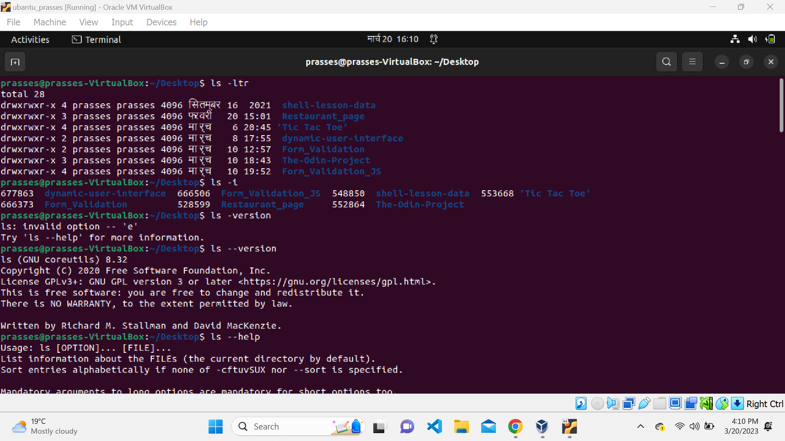

1. Command: **ls --help**

Interpretation: Displays the help guide of the program ls

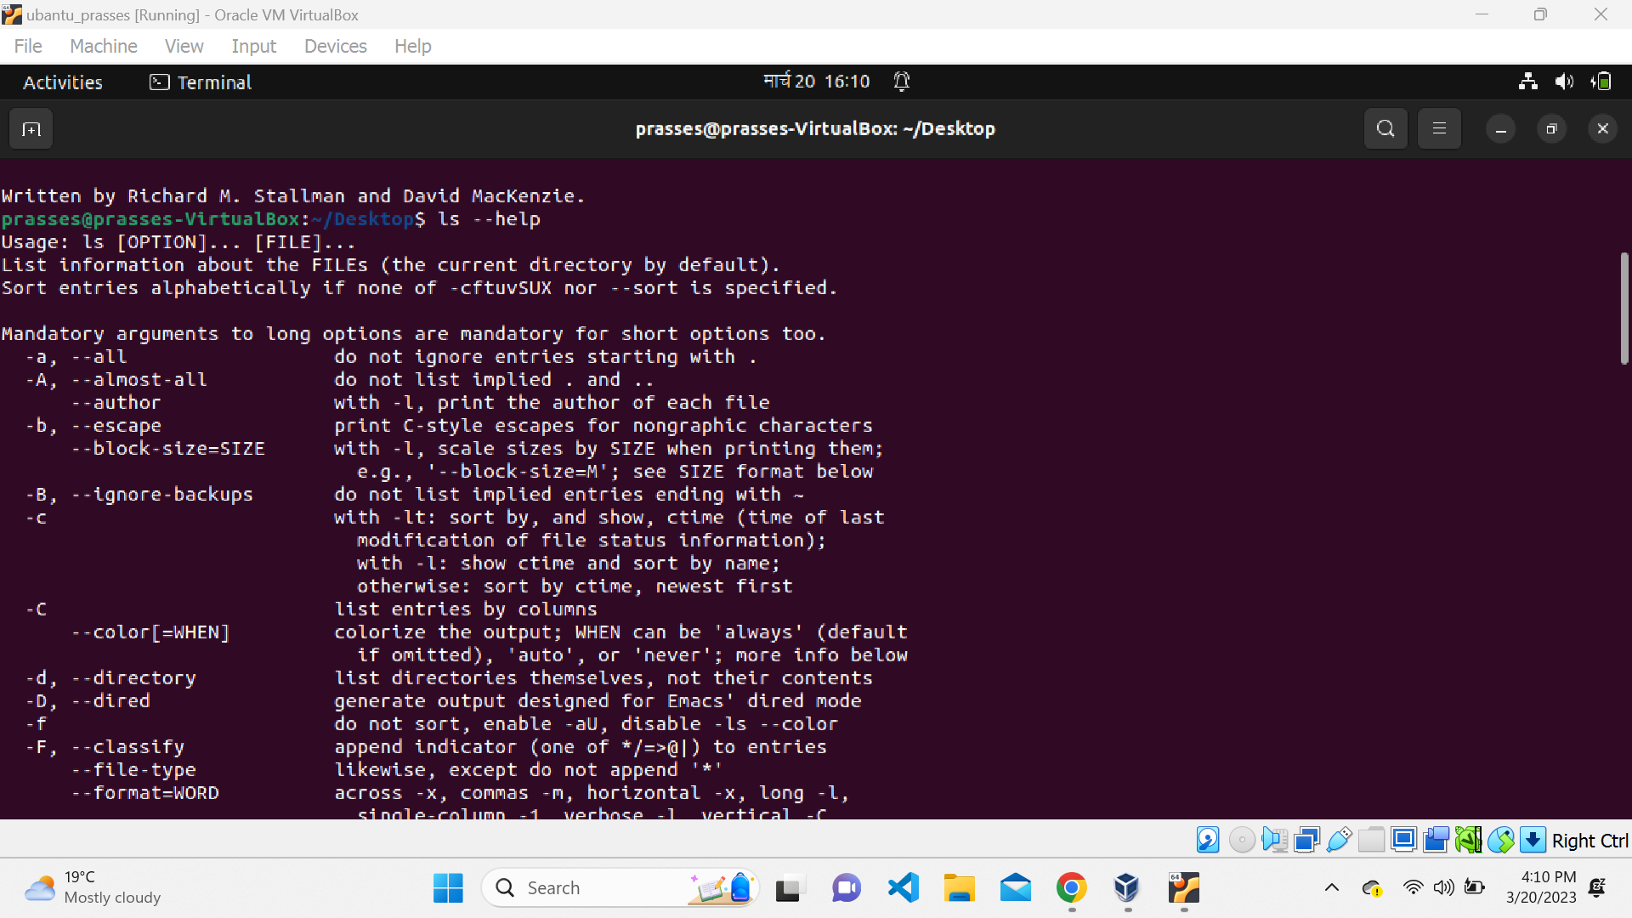

1. Command: **ls -n**

Interpretation: Lists the contents of directory with numeric users and group IDs

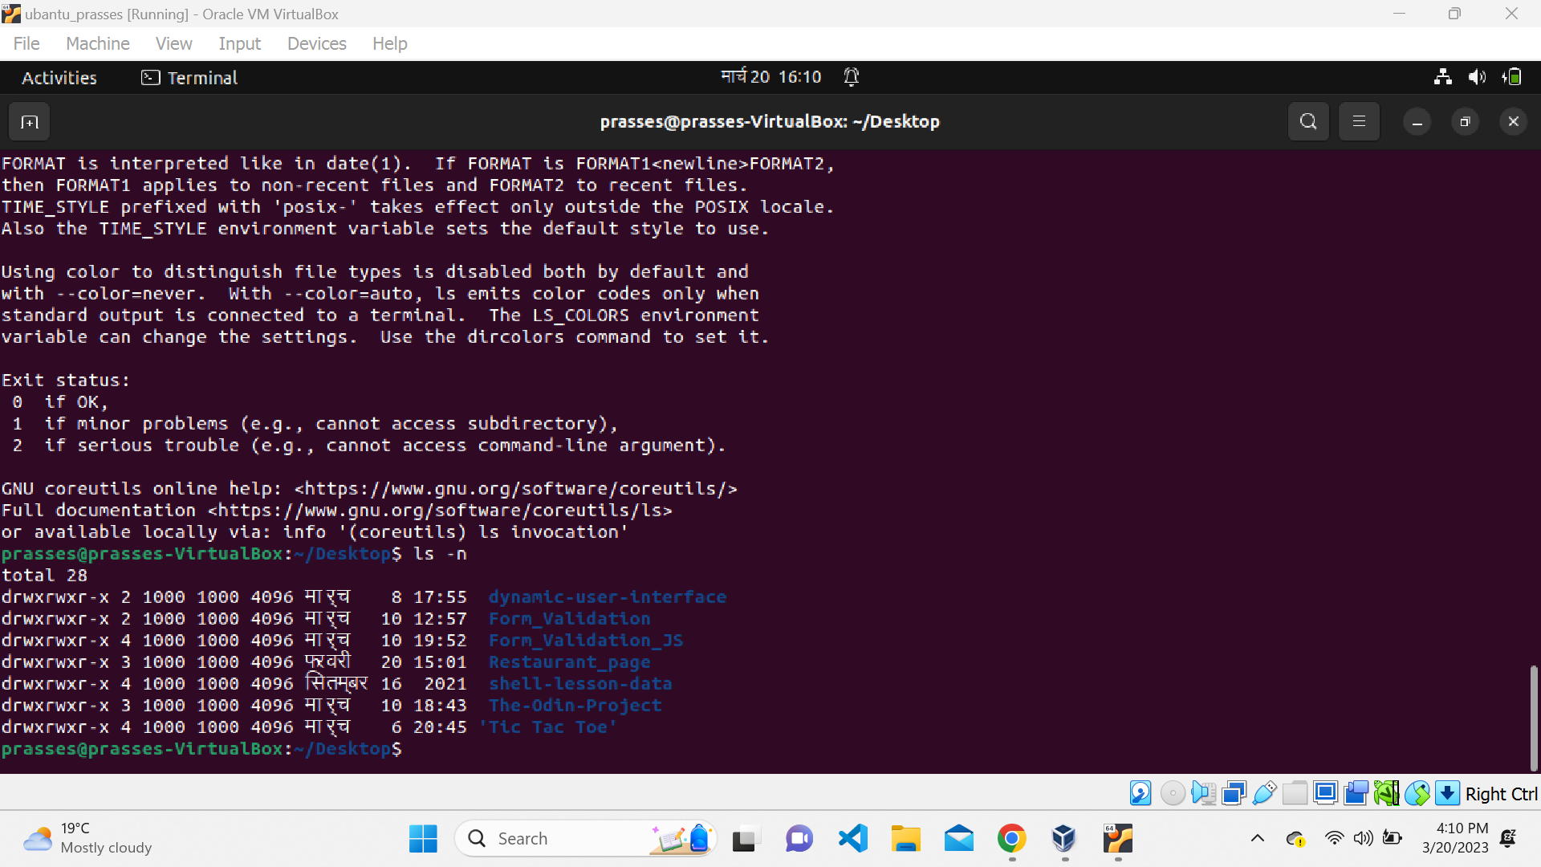

1. Command**: clear**

Interpretation: clear the terminal screen Output:

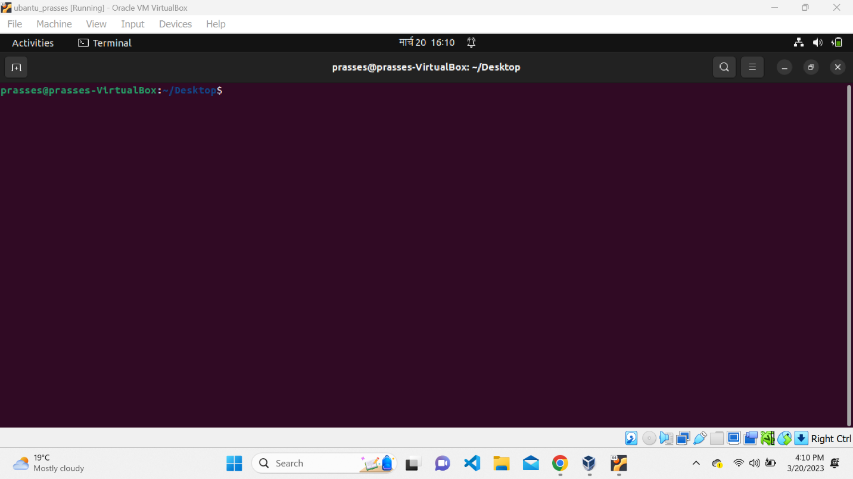

1. Command**: ls**

Output:

1. Command: **mkdir os**

Interpretation: make directories L#B

1. Command: **ls**

Output:

1. Command: **cd os**

Interpretation: changes directory to os in terminal

1. Command: **ls**

Output:

1. Command: **touch** linux.txt

Interpretation: create a file named linux.txt

1. Command: **ls**

Output: 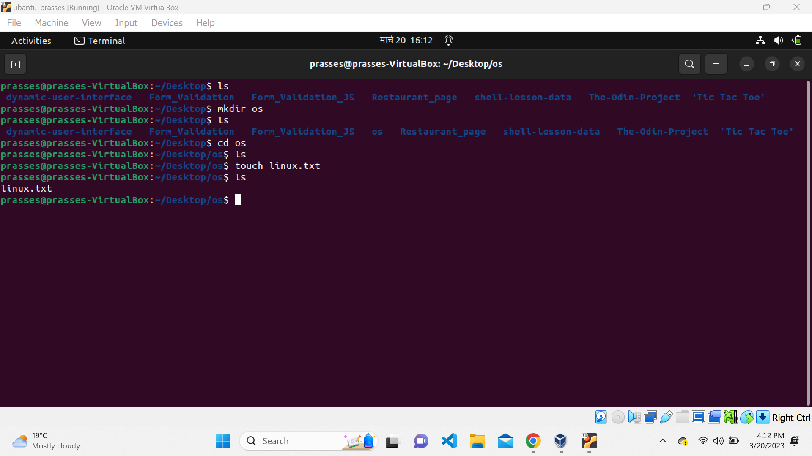

1. Command: **nano** linux.txt

Interpretation: opens the file linux.txt in text editor nano 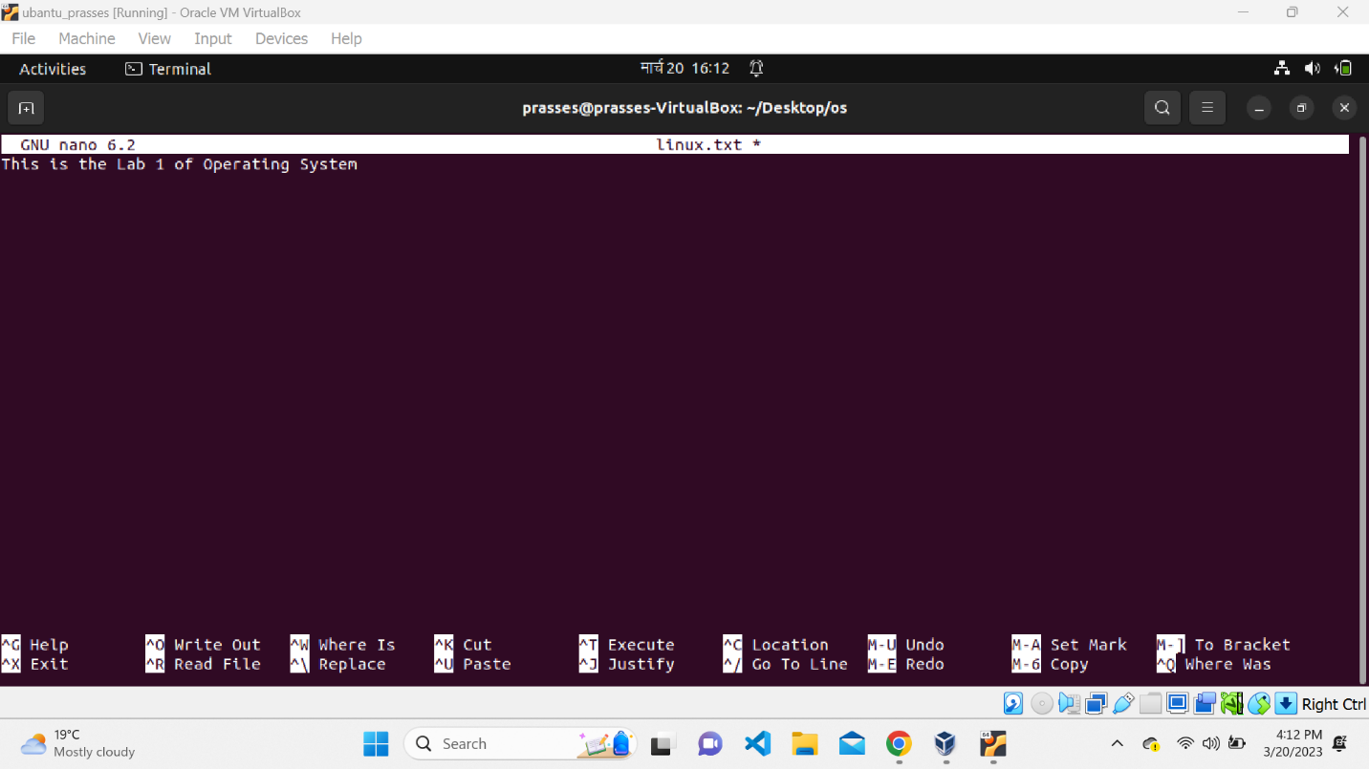

1. Command**: cat** linux.txt

Interpretation: displays content of linux.txt in the terminal

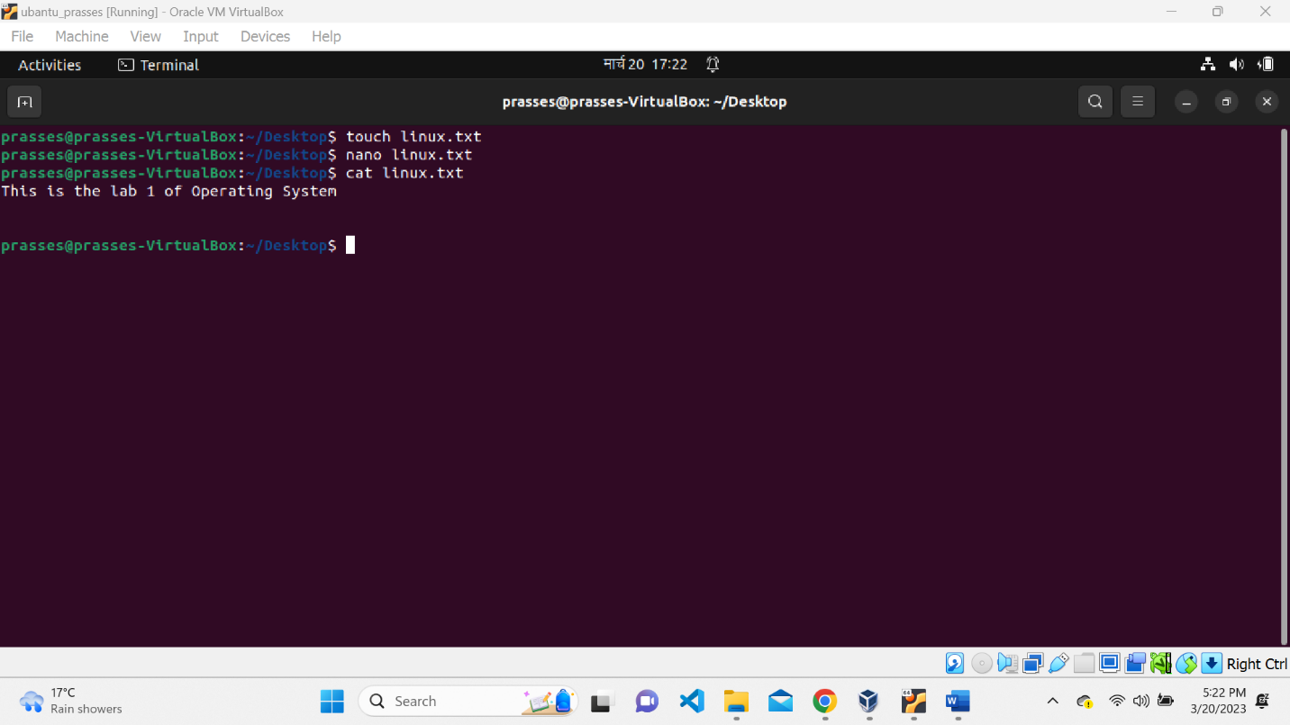

1. Command: **touch** unix.txt

Interpretation: create a file named unix.txt

1. Command: **cat >** unix.txt

Interpretation: allows user to concatanate the text in the file unix.txt and is exited by Ctrl+c

26. Command: **cat** unix.txt

27.Command: **touch** fedora.txt arch.txt debian.txt red_hat.txt

Interpretation: create files named fedora.txt, arch.txt, debian.txt, red_hat.txt

28. Command: **ls**

29. Command: **cp** linux.txt fedora.txt

Interpretation: copy the contents of file linux.txt into file fedora.txt

30. Command: **cat** fedora.txt

31. Command: **cd ..**

Interpretation: change directory to one step back

32. Command: **mkdir** ubuntu

Interpretation: creates the directory named ubuntu

33. Command: **ls**

34. Command: **pwd**

Interpretation: print name of current/working directory

**Output:** 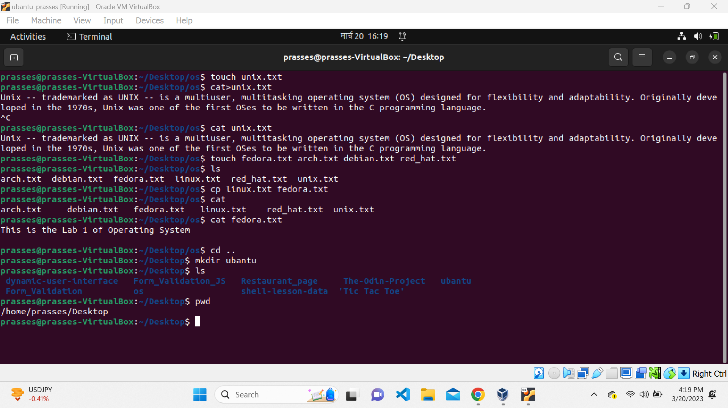

35. Command: **cp** /home/user/os/fedora.txt /home/user/ubuntu

Interpretation: copies the file from directory /home/user/os/fedora.txt to directory/home/user/ubuntu

36. Command: **ls** /home/user/ubuntu

Interpretation: lists the contents of directory /home/user/ubuntu

37. Command: **cat** /home/user/ubuntu/fedora.txt

Interpretation: read the /home/user/ubuntu/fedora.txt and displays it in the terminal

38. Command: **mv** /home/user/os/debian.txt /home/user/ubuntu

Interpretation: move the file /home/user/os/debian.txt to directory /home/user/ubuntu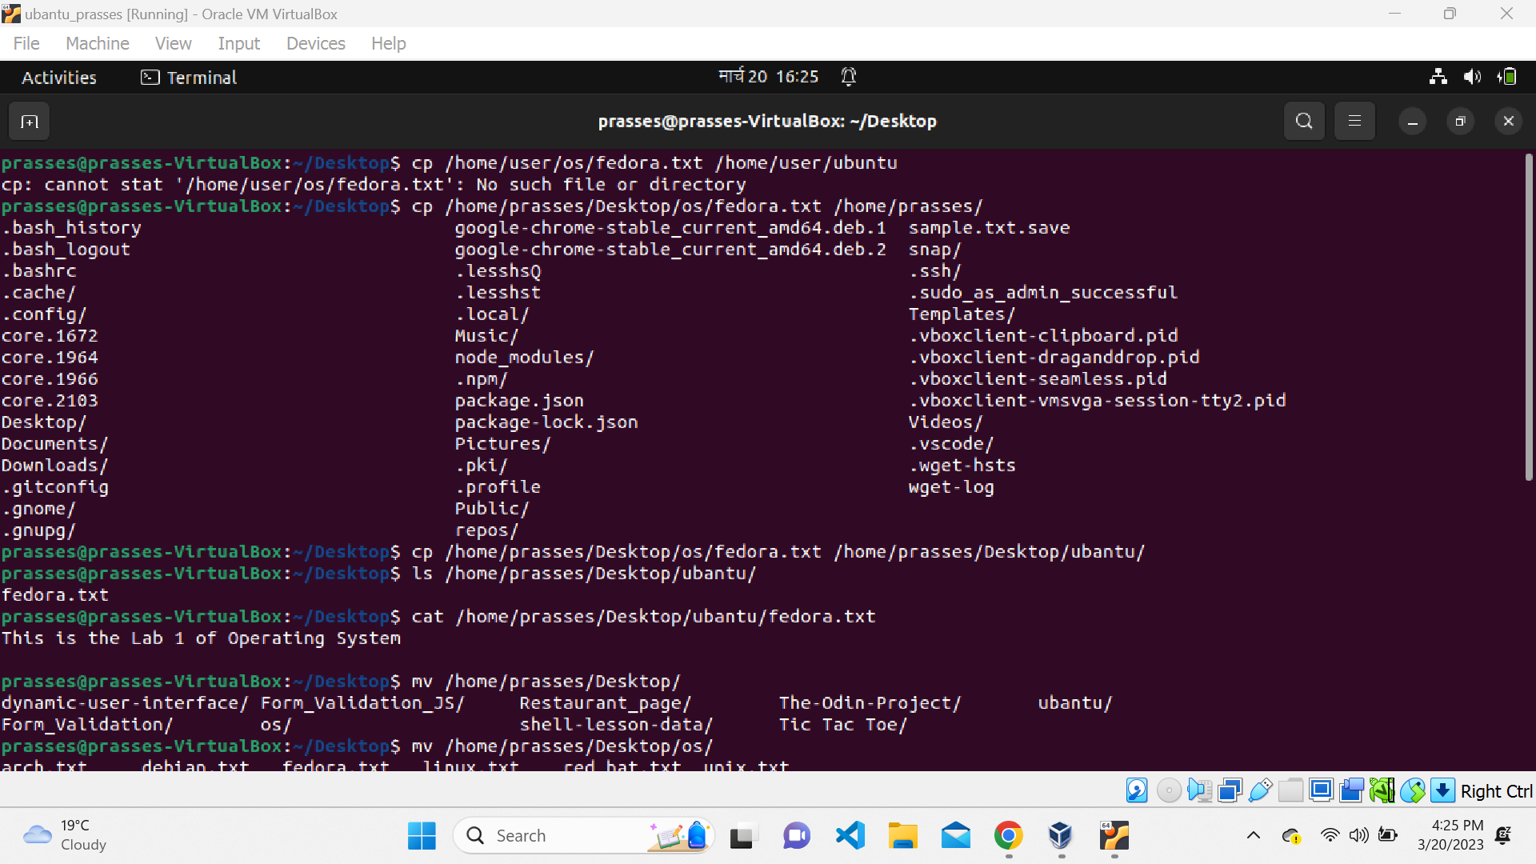

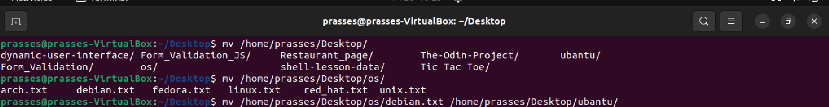

39. Command: **cd** os

40. Command: **ls**

41. Command: **rm** fedora.txt

Interpretation: deletes the file named fedora.txt

42. Command: **ls**

43. Command: **rm** arch.txt linux.txt

Interpretation: deletes the file named arch.txt linux.txt from current working directory

44. Command: **ls**

45. Command**: rm *.**txt

Interpretation: deletes all the files whose name ends with .txt

46. Command: **ls**

47. Command: **cd ..**

48. Command: **rmdir** os

Interpretation: deletes the directory named os from current working directory

49. Command: **ls**

50. Command: **rmdir** ubuntu

Interpretation: deletes the directory named ubuntu when the specified directory is empty

51. Command: **rm -rf** ubuntu

Interpretation: deletes the directory ubuntu and it’s content recursively and forcefully

52. Command: **ls**

